

Name: Sajjal Tariq
- Roll no: 10011
- Section: A
- Submitted to: Mam Ayesha

REVISION LAB 2 (Week 1 - Week 7)

Object-Oriented Programming (C++)

Integrated Concepts: Basics, Classes, Encapsulation, Constructors, Inheritance, Abstraction

Lab Objectives
This revision lab focuses on consolidating core OOP concepts from Weeks 1–7. The tasks are designed to test understanding of encapsulation, constructors, inheritance, and abstraction through practical coding exercises in C++. Each task should include proper class design, code comments, and example output.

Evaluation Criteria
Correct implementation of OOP principles (40%)
Code quality, formatting, and comments (30%)
Output demonstration and explanation (30%)

Student ID |  | Student Name
 | Marks |  | Obtained Marks |  | Comments
Task 1 | 30
Task 2 | 30
Total Marks | 60
 | Lab Instructor

Submission Instructions
1. Complete both tasks using proper class structure and OOP concepts.
2. Paste your C++ source code below each task section.
3. Include screenshots of sample outputs.

TASK 1: Student Result Management System (30 marks)
Concepts Covered: Classes, Encapsulation, Constructors, Constructor Overloading
Scenario: Create a program that manages basic student result information using classes and objects.
- Requirements:
- Define a class `Student` with private members: rollNo, name, and marks for 3 subjects.
- Implement parameterized and default constructors to initialize student data.
- Use setters/getters for encapsulation and input validation (marks between 0–100).
- Add a method `calculateAverage()` that computes the average and displays a grade (A, B, C).
- Demonstrate the use of multiple Student objects and display all results in a formatted output.
- Show example output demonstrating constructor overloading.

Code:
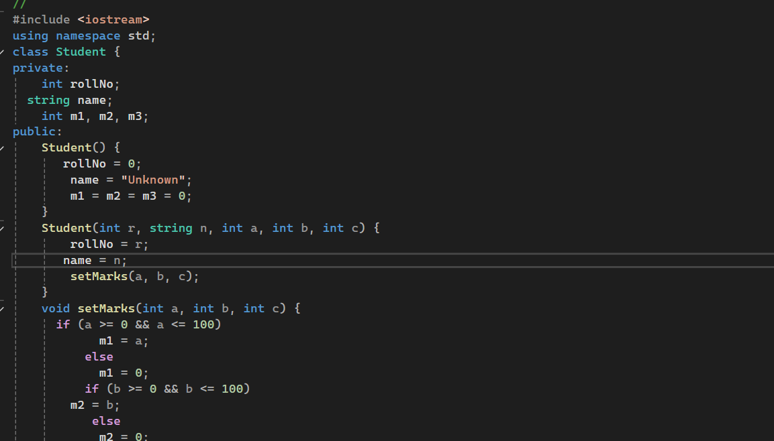
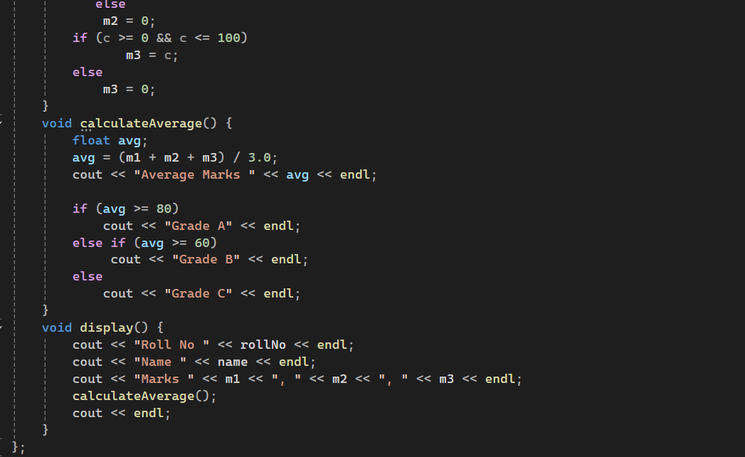
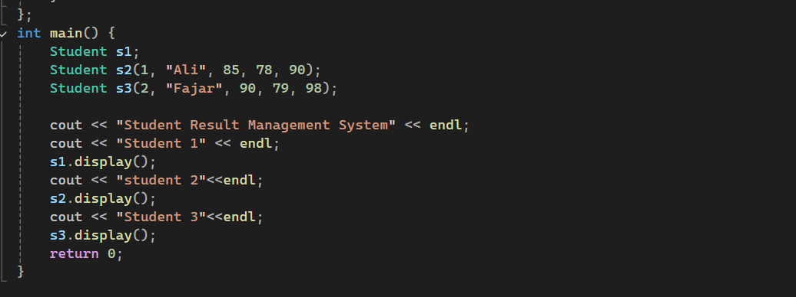
Output:
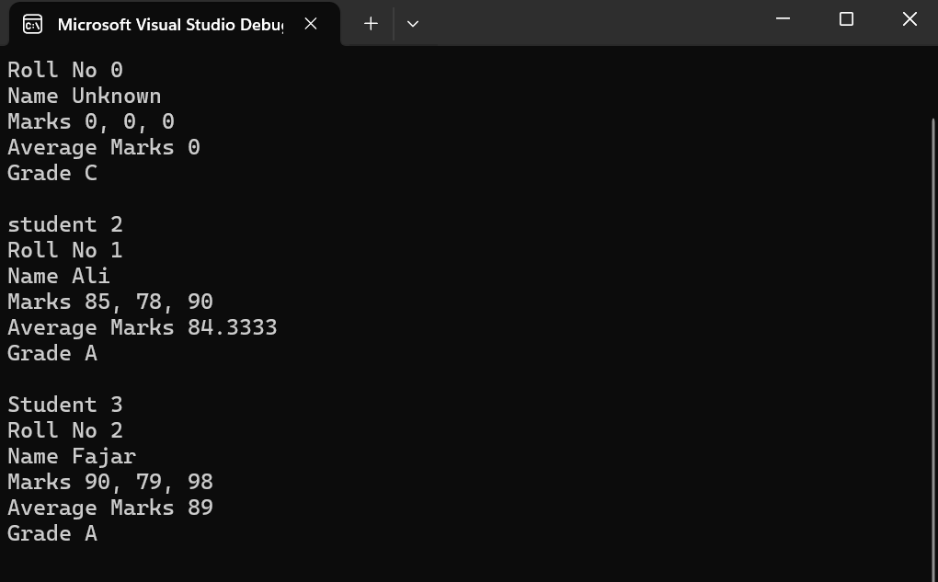

TASK 2: Employee Hierarchy System (30 marks)
Concepts Covered: Inheritance (Single, Multilevel, Hierarchical), Abstraction (Pure Virtual Functions)
Scenario: Build an employee management program to demonstrate inheritance and abstraction concepts.
- Requirements:
- Create an abstract base class `Employee` with members: empID, name, and pure virtual function `calculateSalary()`.
- Derive two classes: `FullTimeEmployee` and `PartTimeEmployee`, implementing salary calculation differently.
- FullTimeEmployee: monthlySalary = basicPay + allowance; PartTimeEmployee: salary = hoursWorked × hourlyRate.
- Add another derived class `Manager` (inheriting from FullTimeEmployee) to demonstrate multilevel inheritance.
- calculateSalary() for different employee types.
- Include at least three employee objects and display their salary details in main().
Code:
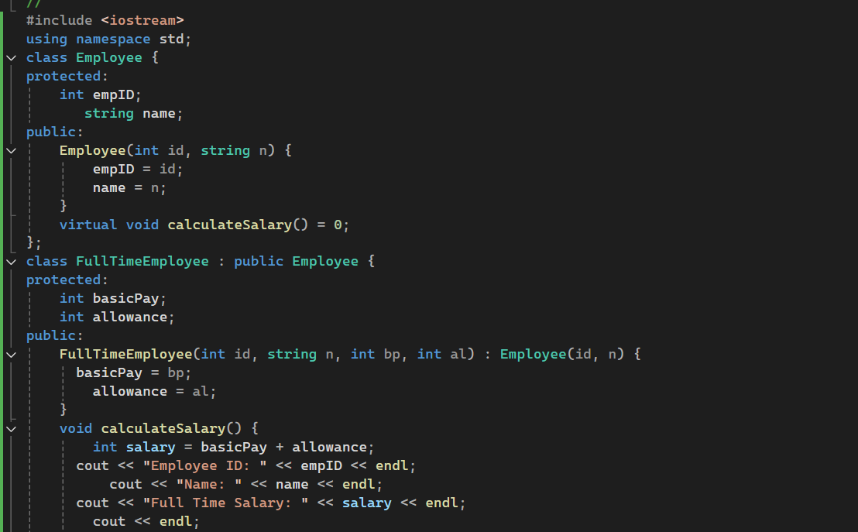
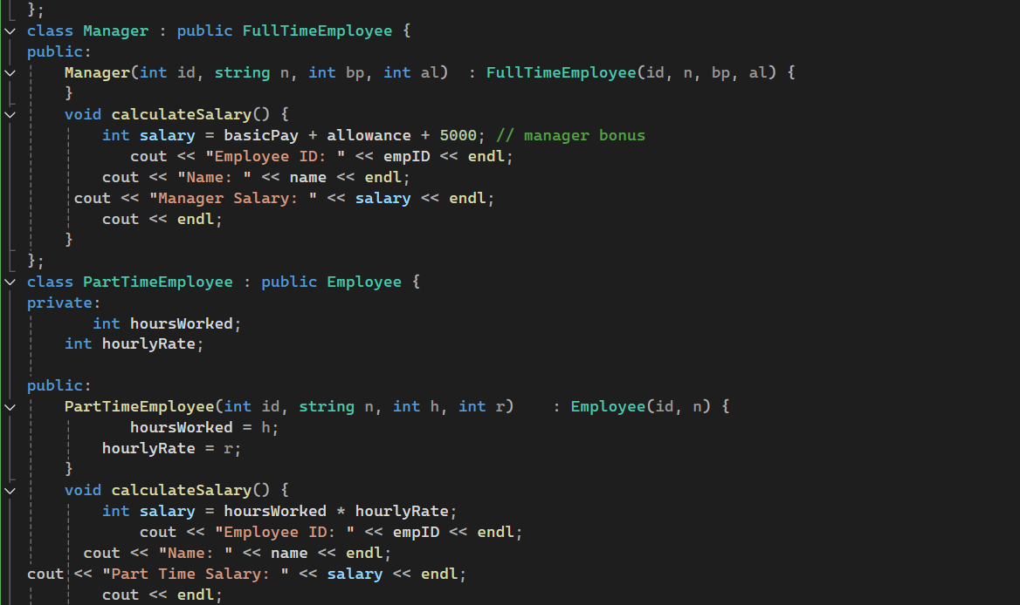
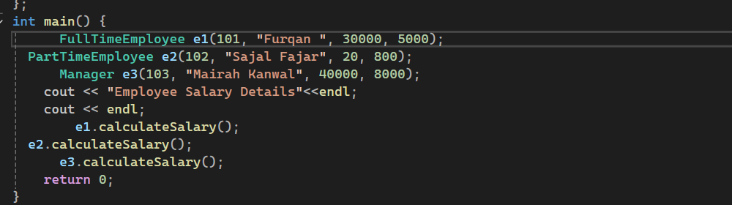
Output:
